* 1. **Component Diagram**

A component diagram describes the organization of the physical components in a system

**Notations used in Component diagram are as follows:**

|  |  |  |
| --- | --- | --- |
| Tool Name | Notation | Description |
| Component | Component | A component is a physical building block of the system. It is represented as a rectangle with tabs.. |
| Associations Roles | Interface | An interface describes a group of operations used or created by components |
| Dependencies | Dependencies | Draw dependencies among components using dashed arrows. |



fig. 3.8.1 : Component Diagram

* 1. **Deployment Diagram**



fig. 3.9.1 : Deployment Diagram

* 1. **Module Specification**

The modules of the purposed project are as follows:

**ADMINISTRATOR:**

1. Manage users.
2. Business information / details.
3. Define business actions.
4. Updation of Information
5. Approvement to new Restaurants
6. Approvement to user Reviews
7. Adding banners and news

**USER:**.

1. Select City
2. Search Restaurants or Kitchen Products or Recipe
3. Create Account
4. Add Products into the wishlist.
5. Give Rating to Restaurants
6. Submit Reviews.
   1. **User Interface Design (home.php)**

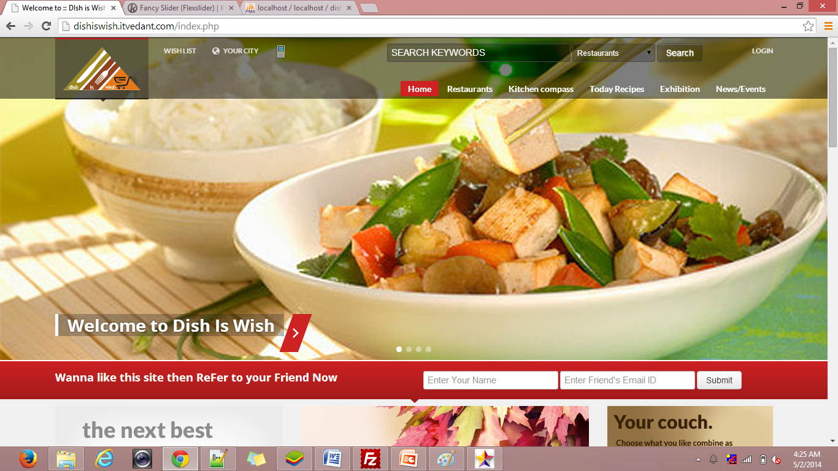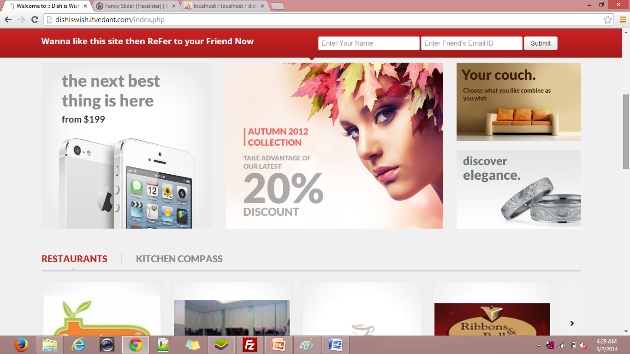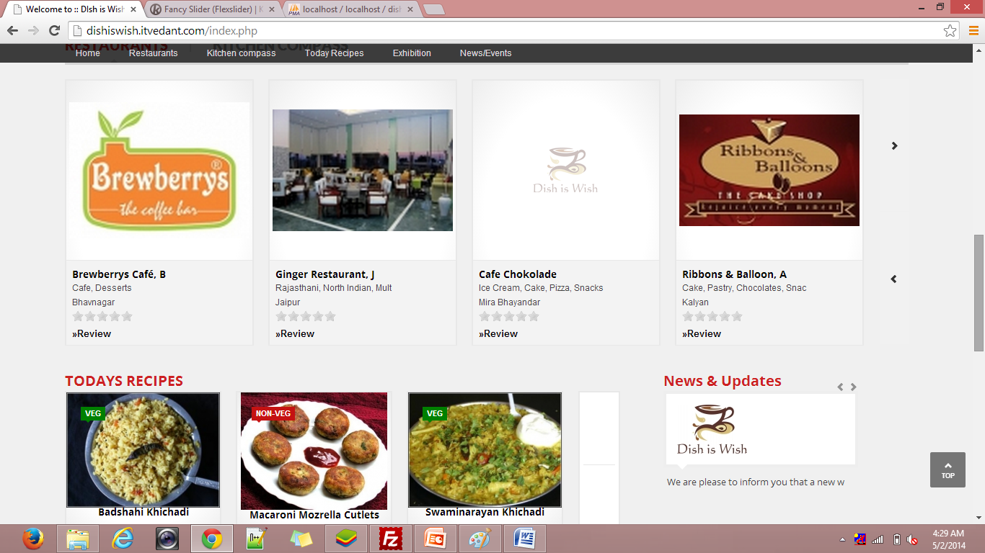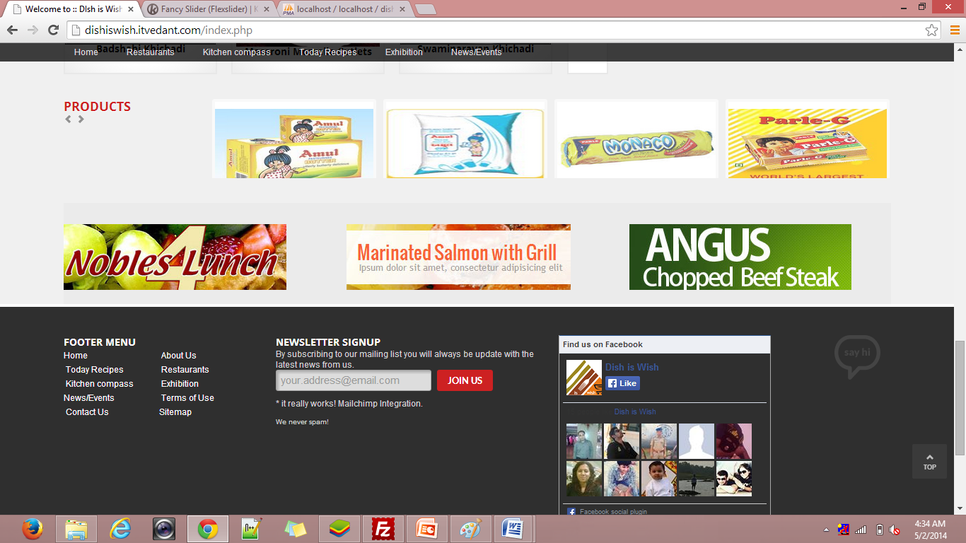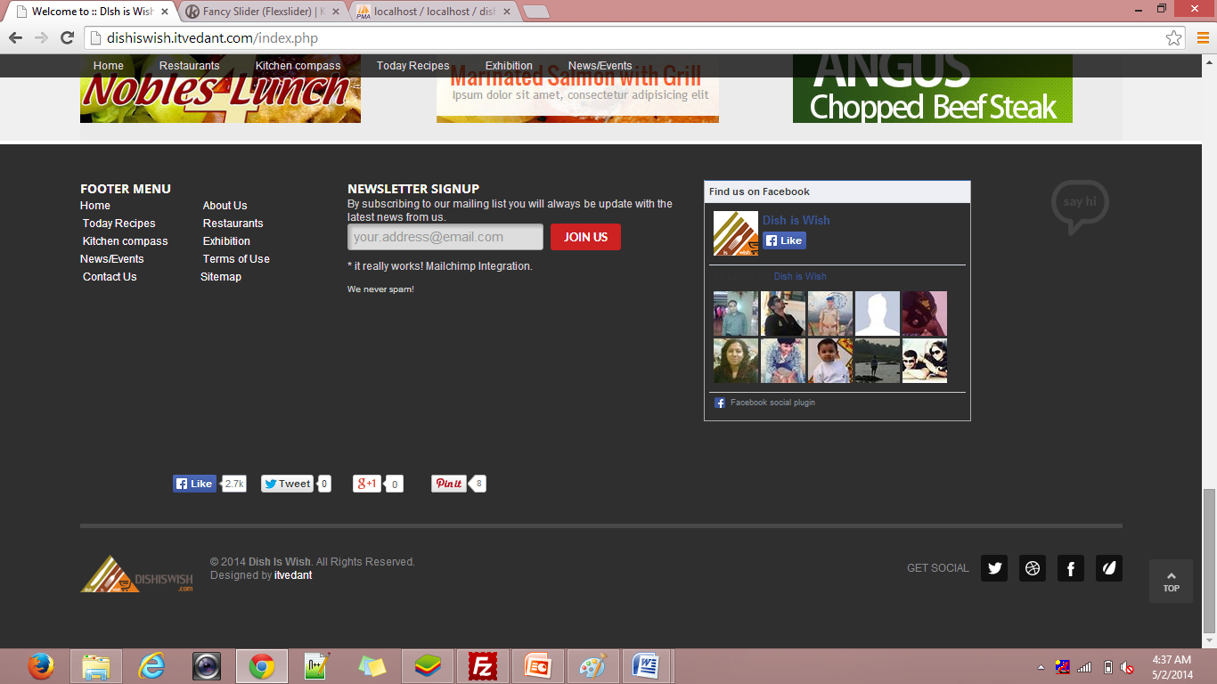

**restaurant_detail.php**

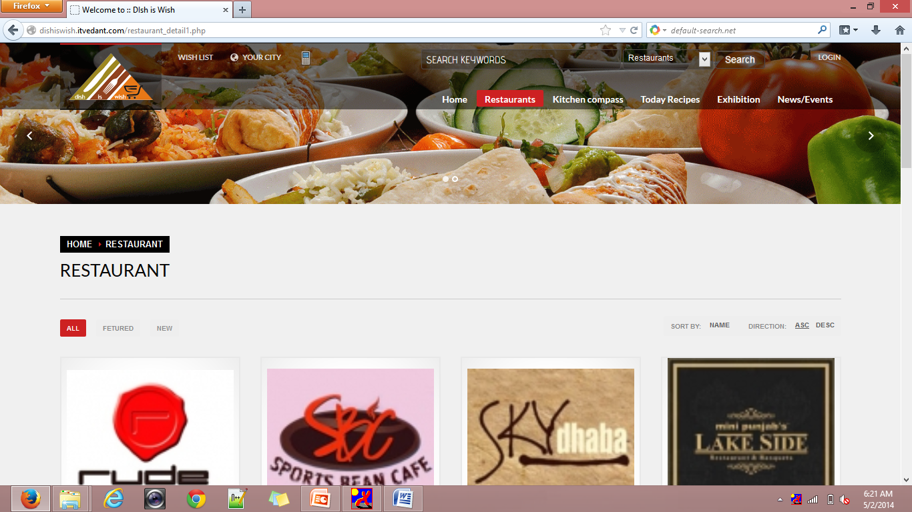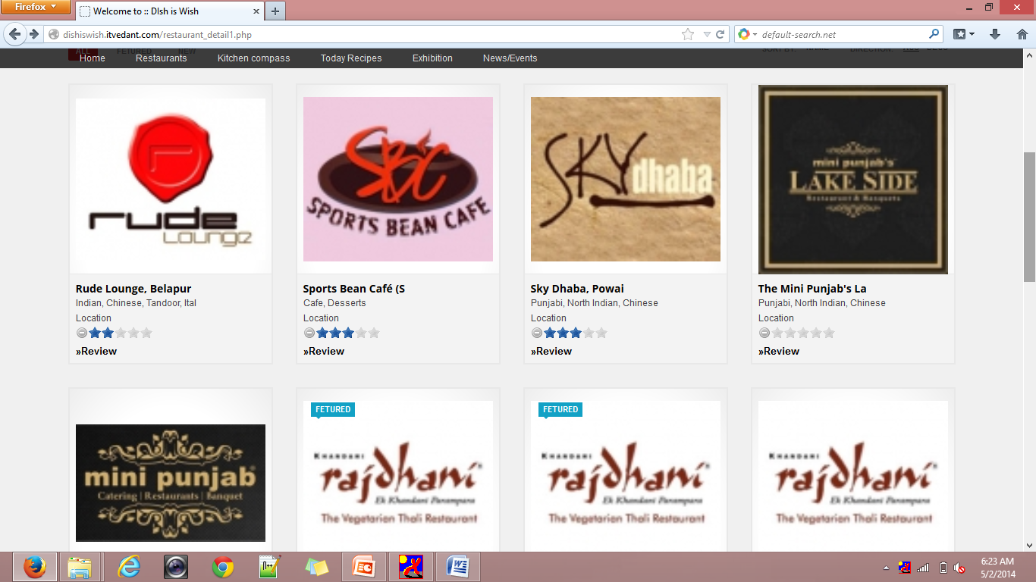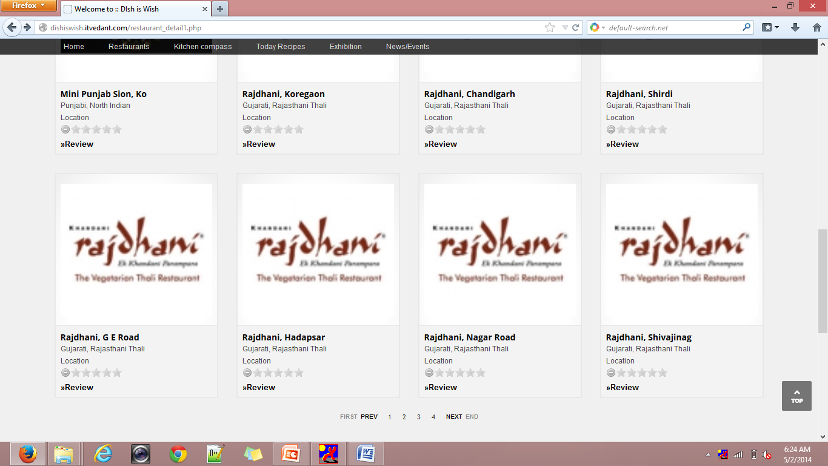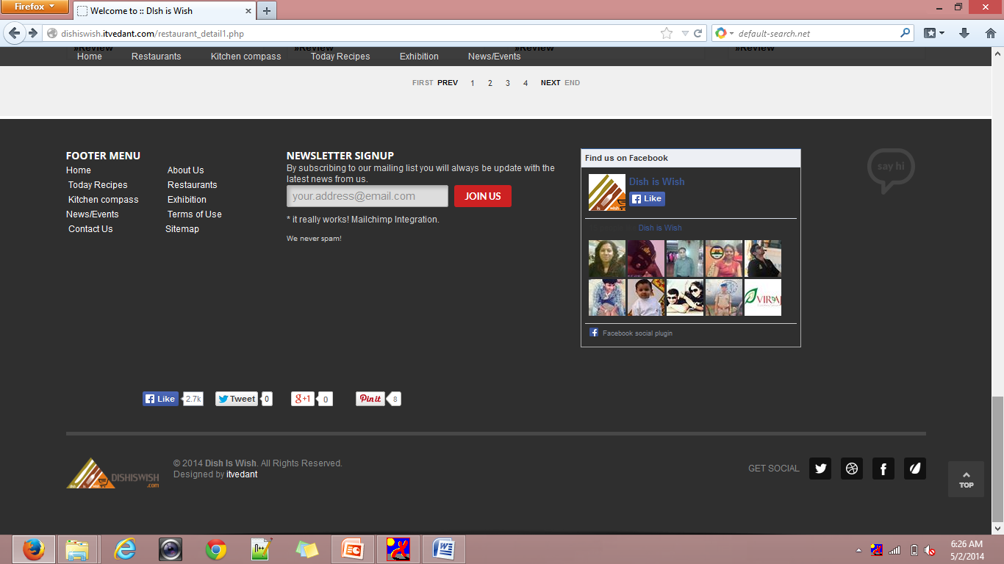

**login.php**

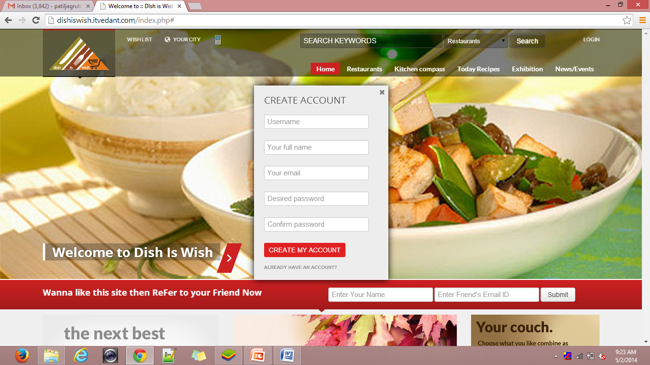

* 1. **Table Specification**

**Admin details**

|  |  |  |  |
| --- | --- | --- | --- |
| **Sr.No** | **Column Name** | **Data Type** | **Constraints** |
| 1 | sl_no | Int(10) | Primary key |
| 2 | user_id | Varchar(50) | Not Null |
| 3 | pwd | Varchar(80) | Not Null |
| 4 | Last_login | Varchar(50) | Not Null |
| 5 | name | Varchar(50) | Not Null |
| 6 | email | Varchar(50) | Not Null |
| 7 | website | Varchar(50) | Not Null |
| 8 | address | text | Not Null |
| 9 | companyName | Varchar(255) | Not Null |
| 10 | phone | Varchar(50) | Not Null |
| 11 | fax | Varchar(50) | Not Null |
| 12 | Footer_text | text | Not Null |

**login**

|  |  |  |  |
| --- | --- | --- | --- |
| **Sr.No** | **Column Name** | **Data Type** | **Constraints** |
| 1 | id | Int(10) | Primary key |
| 2 | username | Varchar(100) | Not Null |
| 3 | Full_name | Varchar(100) | Not Null |
| 4 | email | Varchar(100) | Not Null |
| 5 | pass | Varchar(100) | Not Null |
| 6 | created | date | Not Null |

**restaurant**

|  |  |  |  |
| --- | --- | --- | --- |
| **Sr.No** | **Column Name** | **Data Type** | **Constraints** |
| 1 | restaurantID | Int(11) | Primary key |
| 2 | catID | Int(11) | Not Null |
| 3 | allCategories | text | Not Null |
| 4 | name | Varchar(255) | Not Null |
| 5 | restaurantName | Varchar(255) | Not Null |
| 6 | htmlName | Varchar(100) | Not Null |
| 7 | restaurantEmail | Varchar(255) | Not Null |
| 8 | restaurantwebsite | Varchar(255) | Not Null |
| 9 | image1 | Varchar(50) | Not Null |
| 10 | image2 | Varchar(255) | Not Null |
| 11 | image3 | Varchar(255) | Not Null |
| 12 | image4 | Varchar(255) | Not Null |
| 13 | image5 | Varchar(255) | Not Null |
| 14 | image6 | Varchar(255) | Not Null |
| 15 | pricePerPlate | Float(10.2) | Not Null |
| 16 | openingTimings | Varchar(255) | Not Null |

**city_tbl**

|  |  |  |  |
| --- | --- | --- | --- |
| **Sr.No** | **Column Name** | **Data Type** | **Constraints** |
| 1 | StateID | Int(11) | Primary key |
| 2 | stateName | Varchar(255) | NotNull |

**News**

|  |  |  |  |
| --- | --- | --- | --- |
| **Sr.No** | **Column Name** | **Data Type** | **Constraints** |
| 1 | slno | Int(11) | Primary key |
| 2 | newsHeading | Varchar(255) | Not Null |
| 3 | newsShortDescription | text | Not Null |
| 4 | newsDescription | longtext | Not Null |
| 5 | newsLink | Varchar(100) | Not Null |
| 6 | newsImage | Varchar(255) | Not Null |
| 7 | newsVenue | text | Not Null |
| 8 | featuredNews | char(1) | Not Null |
| 9 | addedOn | datetime | Not Null |
| 10 | status | char(1) | Not Null |

**recipie**

|  |  |  |  |
| --- | --- | --- | --- |
| **Sr.No** | **Column Name** | **Data Type** | **Constraints** |
| 1 | slno | Int(11) | Primary Key |
| 2 | recipeName | Varchar(250) | Not Null |
| 3 | restaurantName | Varchar(250) | Not Null |
| 4 | restaurantWebsite | Varchar(250) | Not Null |
| 5 | contactAddress | text | Not Null |
| 6 | contactDetails | text | Not Null |
| 7 | shortDescription | longtext | Not Null |
| 8 | completeDescription | longtext | Not Null |
| 9 | pricePerPlate | float(10.2) | Not Null |
| 10 | recipeImage | Varchar(255) | Not Null |
| 11 | recipeFile | Varchar(255) | Not Null |
| 12 | recipeIngredients | text | Not Null |
| 13 | chefChoice | char(1) | Not Null |
| 14 | pureVegetarian | char(1) | Not Null |
| 15 | showOnHomePage | char(1) | Not Null |
| 16 | addedOn | date | Not Null |
| 17 | status | char(1) | Not Null |

**Kitchen_compass**

|  |  |  |  |
| --- | --- | --- | --- |
| **Sr.No** | **Column Name** | **Data Type** | **Constraints** |
| 1 | restaurantID | Int(11) | Primary Key |
| 2 | catID | Int(11) | Not Null |
| 3 | allCategories | text | Not Null |
| 4 | cuisins | Varchar(255) | Not Null |
| 5 | restaurantName | Varchar(255) | Not Null |
| 6 | htmlName | Varchar(100) | Not Null |
| 7 | restaurantEmail | Varchar(255) | Not Null |
| 8 | restaurantWebsite | Varchar(255) | Not Null |
| 9 | image1 | Varchar(50) | Not Null |
| 10 | image2 | Varchar(255) | Not Null |
| 11 | image3 | Varchar(255) | Not Null |
| 12 | image4 | Varchar(255) | Not Null |
| 13 | image5 | Varchar(255) | Not Null |
| 14 | image6 | Varchar(255) | Not Null |
| 15 | openingTimings | Varchar(255) | Not Null |
| 16 | contactAddress | text | Not Null |
| 17 | contactDetails | text | Not Null |
| 18 | shortDescription | text | Not Null |
| 19 | completeDescrption | longtext | Not Null |
| 20 | googleMapCode | text | Not Null |
| 21 | location | Varchar(255) | Not Null |

**wishlist**

|  |  |  |  |
| --- | --- | --- | --- |
| **Sr.No** | **Column Name** | **Data Type** | **Constraints** |
| 1 | wish_id | Int(100) | Not Null |
| 2 | wishitem_id | Int(100) | Not Null |
| 3 | value | Int(11) | Not Null |
| 4 | flag | Int(11) | Not Null |
| 5 | created | datetime | Not Null |

**brand**

|  |  |  |  |
| --- | --- | --- | --- |
| **Sr.No** | **Column Name** | **Data Type** | **Constraints** |
| 1 | brand_id | Int(100) | Primary Key |
| 2 | brand_name | Varchar(100) | Not Null |
| 3 | brand_picture | Varchar(100) | Not Null |
| 4 | speciication | Varchar(200) | Not Null |
| 5 | flag | Int(11) | Not Null |
| 6 | created | datetime | Not Null |

**Enquiry_tbl**

|  |  |  |  |
| --- | --- | --- | --- |
| **Sr.No** | **Column Name** | **Data Type** | **Constraints** |
| 1 | slno | Int(11) | Primary Key |
| 2 | enquiryType | Varchar(100) | Not Null |
| 3 | firstName | Varchar(50) | Not Null |
| 4 | lastName | Varchar(50) | Not Null |
| 5 | companyName | Varchar(80) | Not Null |
| 6 | subject | Varchar(255) | Not Null |
| 7 | email | Varchar(50) | Not Null |
| 8 | phone | Varchar(20) | Not Null |
| 9 | mobile | Varchar(255) | Not Null |
| 10 | fax | Varchar(50) | Not Null |
| 11 | address | text | Not Null |
| 12 | city | Varchar(50) | Not Null |
| 13 | state | Varchar(50) | Not Null |
| 14 | country | Varchar(50) | Not Null |
| 15 | zipcode | Varchar(20) | Not Null |
| 16 | comments | text | Not Null |
| 17 | source | char(1) | Not Null |
| 18 | product | Varchar(100) | Not Null |
| 19 | restaurantName | Varchar(255) | Not Null |
| 20 | website | Varchar(255) | Not Null |
| 21 | openingTime | Varchar(255) | Not Null |
| 22 | status | char(1) | Not Null |
| 23 | recvDate | datetime | Not Null |

**Newsletter_member**

|  |  |  |  |
| --- | --- | --- | --- |
| **Sr.No** | **Column Name** | **Data Type** | **Constraints** |
| 1 | id | Int(10) | Primary Key |
| 2 | name | Varchar(30) | Not Null |
| 3 | email | Varchar(50) | Not Null |
| 4 | Join_date | date | Not Null |
| 5 | status | char(2) | Not Null |
| 6 | mail_status | char(2) | Not Null |

**product**

|  |  |  |  |
| --- | --- | --- | --- |
| **Sr.No** | **Column Name** | **Data Type** | **Constraints** |
| 1 | product_id | Int(100) | Primary Key |
| 2 | product_name | Varchar(100) | Not Null |
| 3 | product_picture | Varchar(100) | Not Null |
| 4 | specification | Varchar(200) | Not Null |
| 5 | brand_id | Int(100) | Foreign Key |
| 6 | flag | Int(11) | Not Null |
| 7 | created | datetime | Not Null |

**Compass_rating_tbl**

|  |  |  |  |
| --- | --- | --- | --- |
| **Sr.No** | **Column Name** | **Data Type** | **Constraints** |
| 1 | slno | Int(11) | Primary Key |
| 2 | restaurantID | Int(11) | Not Null |
| 3 | rating | Int(11) | Not Null |
| 4 | ipAddress | Varchar(255) | Not Null |
| 5 | status | Char(1) | Not Null |
| 6 | createdDate | datetime | Not Null |

**Restaurant_rating_tbl**

|  |  |  |  |
| --- | --- | --- | --- |
| **Sr.No** | **Column Name** | **Data Type** | **Constraints** |
| 1 | slno | Int(11) | Primary Key |
| 2 | restaurantID | Int(11) | Not Null |
| 3 | rating | Int(11) | Not Null |
| 4 | ipAddress | Varchar(255) | Not Null |
| 5 | status | Char(1) | Not Null |
| 6 | createdDate | datetime | Not Null |

**static_pages**

|  |  |  |  |
| --- | --- | --- | --- |
| **Sr.No** | **Column Name** | **Data Type** | **Constraints** |
| 1 | pageID | Int(11) | Primary Key |
| 2 | pageTitle | Varchar(255) | Not Null |
| 3 | pageDesc | text | Not Null |
| 4 | status | Char(1) | Not Null |

**Restaurant_review_tbl**

|  |  |  |  |
| --- | --- | --- | --- |
| **Sr.No** | **Column Name** | **Data Type** | **Constraints** |
| 1 | slno | Int(11) | Primary Key |
| 2 | restaurantID | Int(11) | Not Null |
| 3 | name | Varchar(255) | Not Null |
| 4 | email | Varchar(255) | Not Null |
| 5 | comments | text | Not Null |
| 6 | rating | Int(11) | Not Null |
| 7 | status | Char(1) | Not Null |
| 8 | createdDate | datetime | Not Null |

**Compass_review_tbl**

|  |  |  |  |
| --- | --- | --- | --- |
| **Sr.No** | **Column Name** | **Data Type** | **Constraints** |
| 1 | slno | Int(11) | Primary Key |
| 2 | restaurantID | Int(11) | Not Null |
| 3 | name | Varchar(255) | Not Null |
| 4 | email | Varchar(255) | Not Null |
| 5 | comments | text | Not Null |
| 6 | rating | Int(11) | Not Null |
| 7 | staus | Char(1) | Not Null |
| 8 | createdDate | datetime | Not Null |

**Flash_banner_tbl**

|  |  |  |  |
| --- | --- | --- | --- |
| **Sr.No** | **Column Name** | **Data Type** | **Constraints** |
| 1 | slno | Int(11) | Primary Key |
| 2 | bannerUrl | Varchar(150) | Not Null |
| 3 | bannerImage | Varchar(100) | Not Null |
| 4 | bannerText | text | Not Null |
| 5 | activeDate | date | Not Null |
| 6 | expiryDate | date | Not Null |
| 7 | status | Char(1) | Not Null |

1. **User Manual**

Main Menu Bar

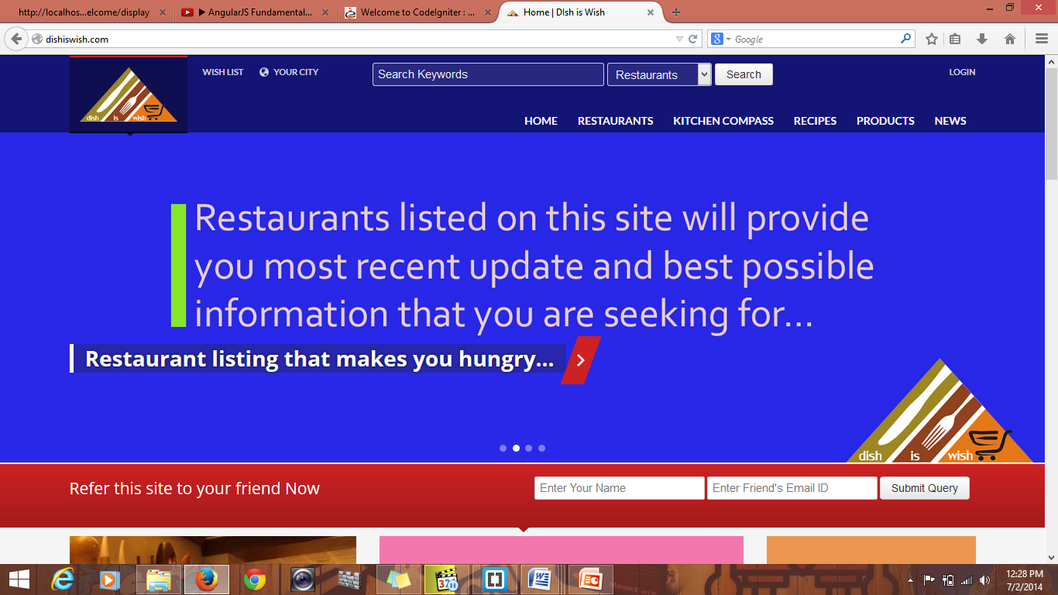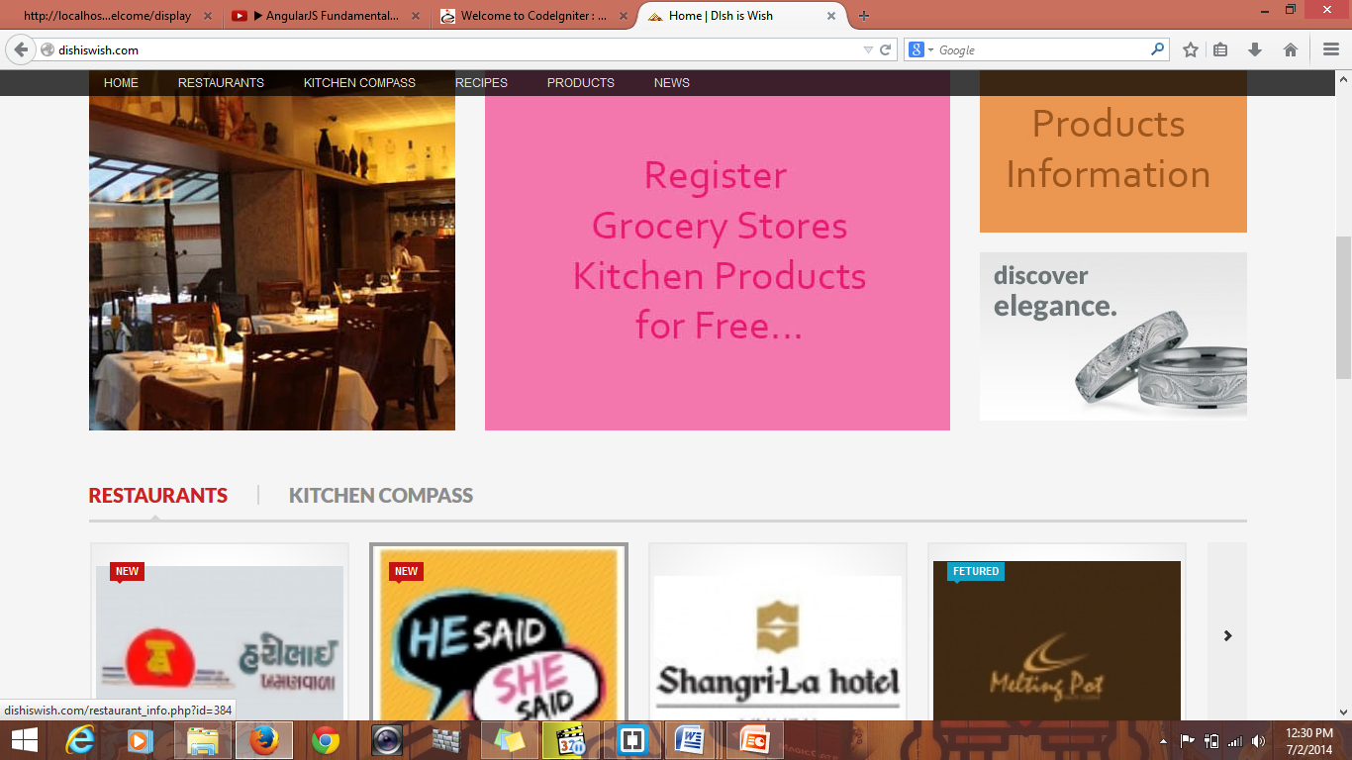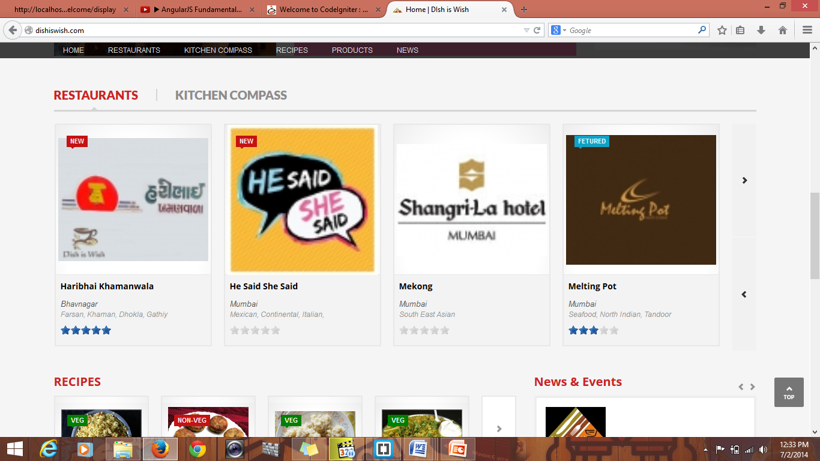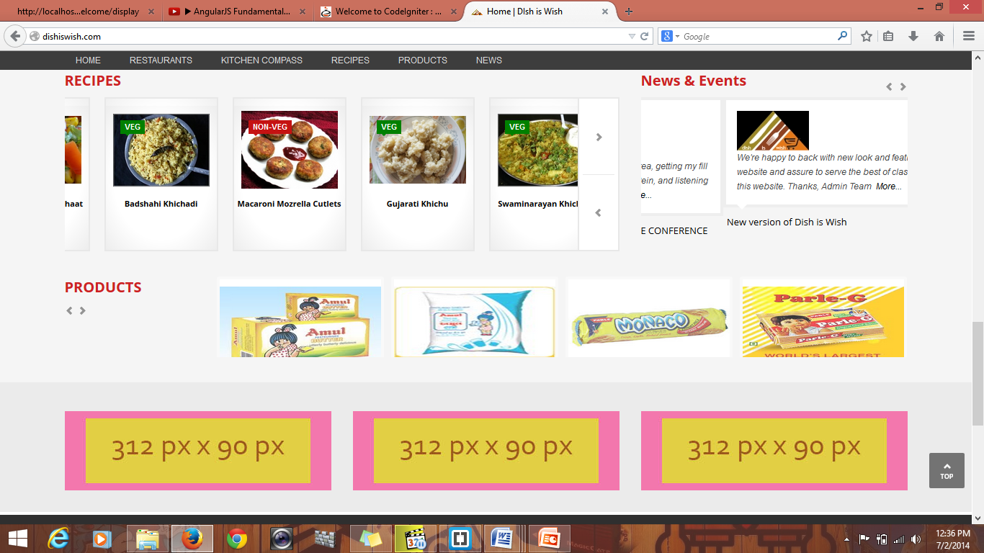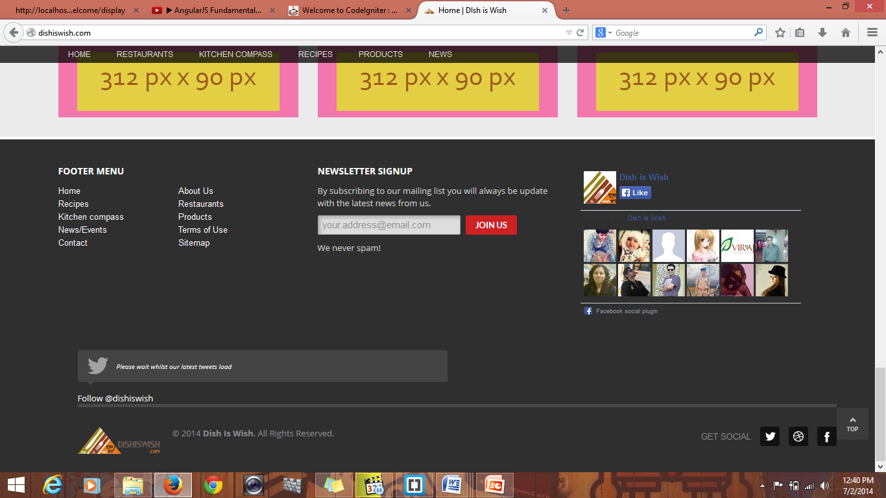

Footer

Product Slider

Recipes and news slider

Restaurants and kitchen products

**Mannual for user**

**For visitor**

* Select your city then it displays city wise listing of restaurant and kitchen compass.
* For detail listing use Main maenu bar.
* You can see links for About us, contact us and other links.
* If you want more functionality ,first register yourself then addto wishlist and reviews functionality will work.

**For Member**

* If you are member then first login .
* Select your City.
* You can add restaurants and kitchen products into your wishlist.
* Send Review and you also can add your restaurant.

1. **Drawbacks And Limitation**

The limitations of the website are as follows:

* The user has to be computer literate.
* Website will not work in case of internet unavailability
* The website will not work in case of power failure or disconnect the internet

1. **Proposed Enhancements**

* Location Tracking Facility
* Can add Additional information
* Discount for Restaurants if you are searching through this website

1. **conclustion**

* The quality and the reliability of the software depend on the result of the phase of the system development. The software quality includes the modularity, good documentation, user friendliness, maintainability, etc
* The software reliability depends on the less chance of failure and enhancement in the system given in the stressed situation. As far as our system is concerned we have tried to make the system as user friendly as possible where layman can handle the system very comfortably.
* During detailed design the system is designed into modules so it is easy to Understand and helpful to the management.

1. **BIBLIOGRAPHY**

**Reference Books:-**

* + PHP 5.1 for beginners.

*Author: - Ivan Bayross and Sharanam Shah*

* + Head First PHP and MYSQL

*Author: - Lynn Beingley and Micheal Morrison.*

**Websites:-**

* *www.php.net*
* *www.w3schools.com*
* *www.tizag.com*
* [*www.stackoverflow.com*](http://www.stackoverflow.com)
* [*www.bootstrap.com*](http://www.bootstrap.com)
* [*www.jquery.com*](http://www.jquery.com)

**ANNEXURES**

**ANNEXURE 1 : INPUT FORMS WITH DATA**

**Registration form**

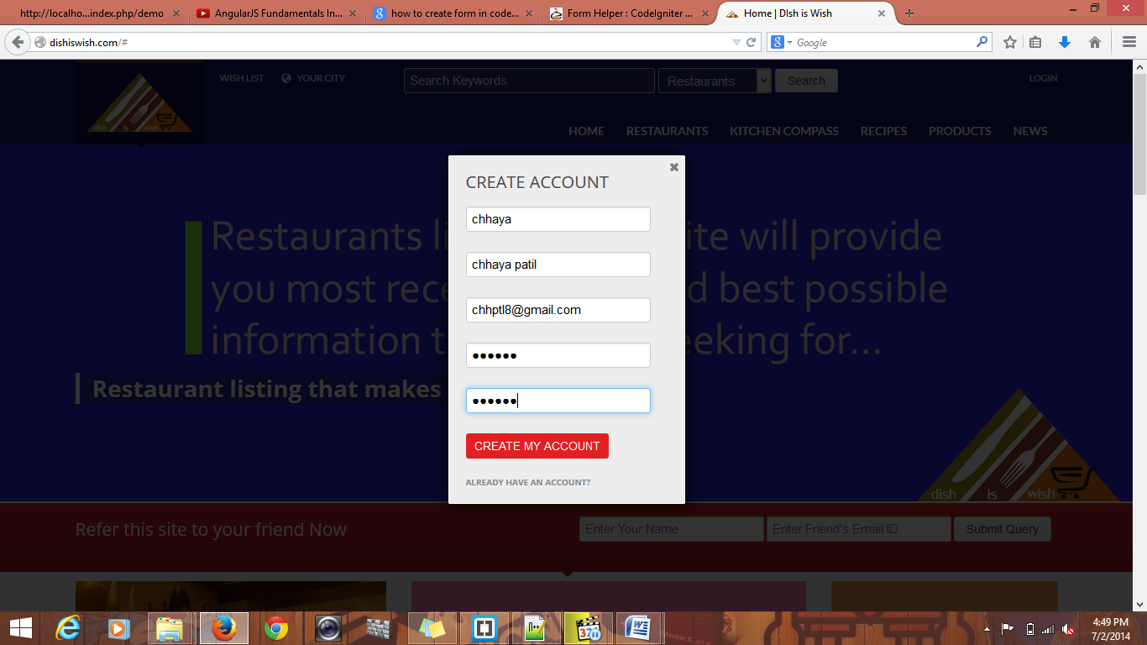

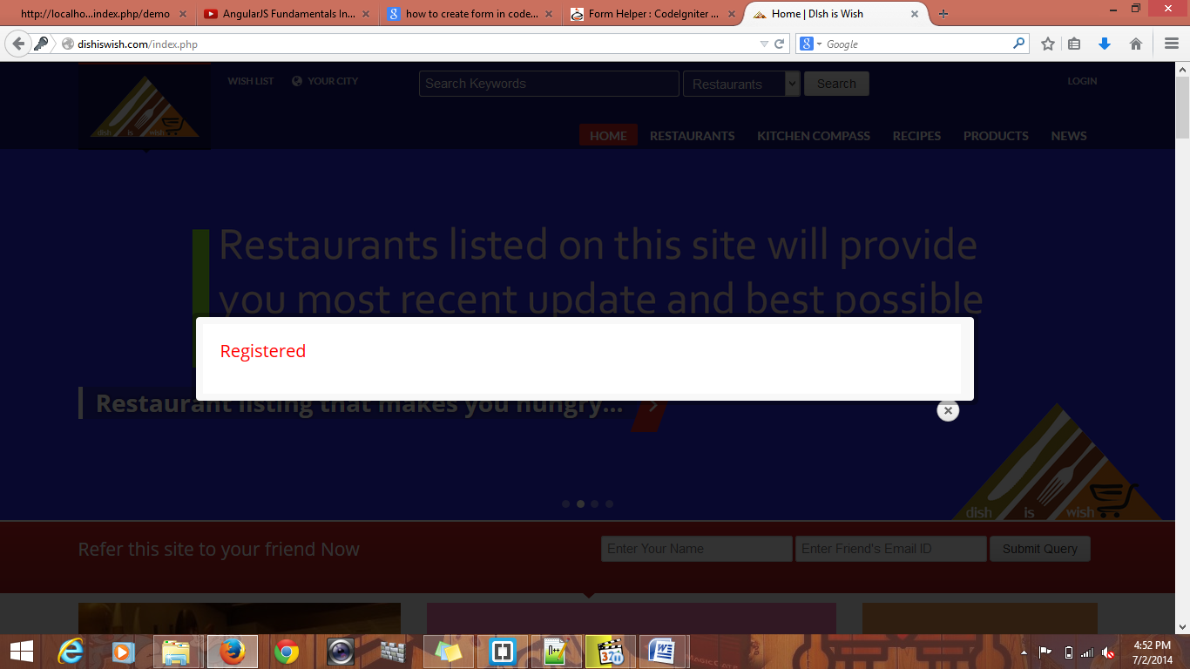

**Contact_us Form**

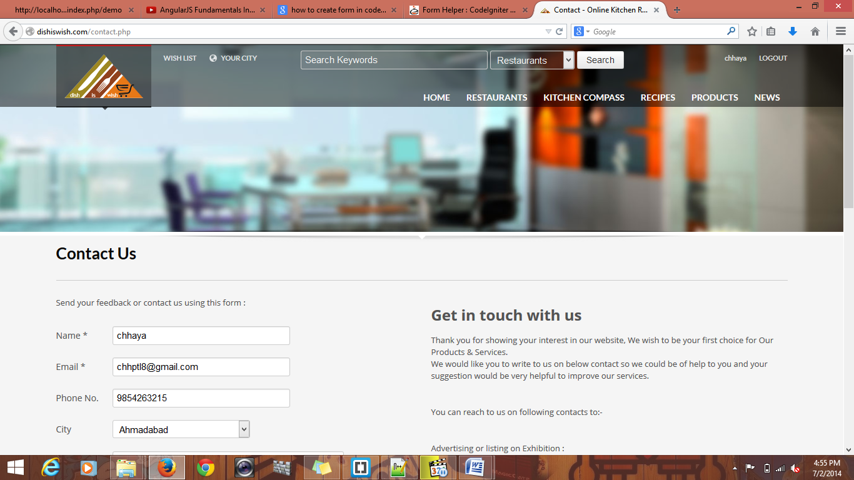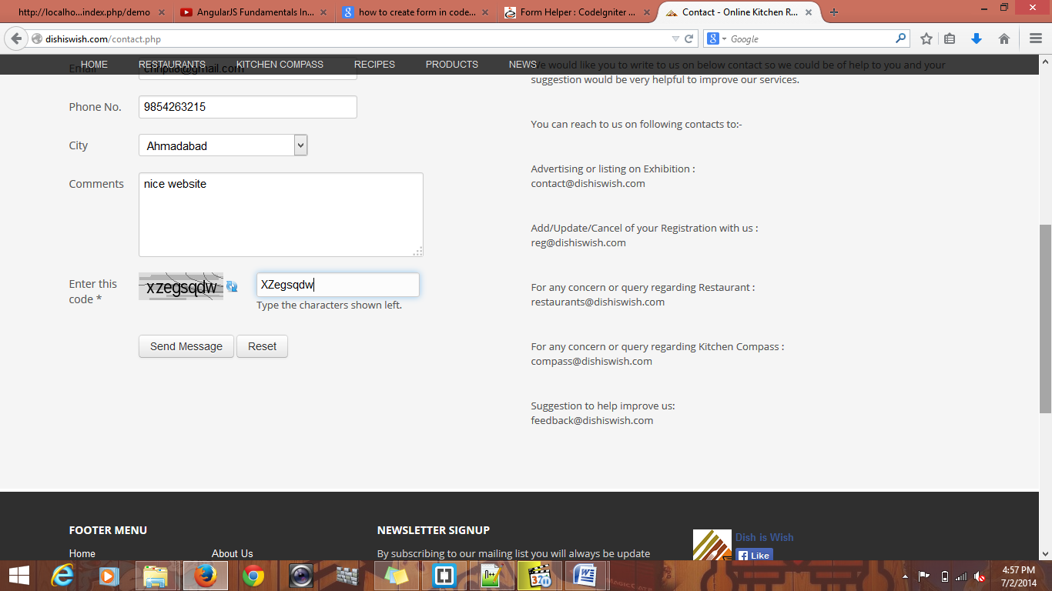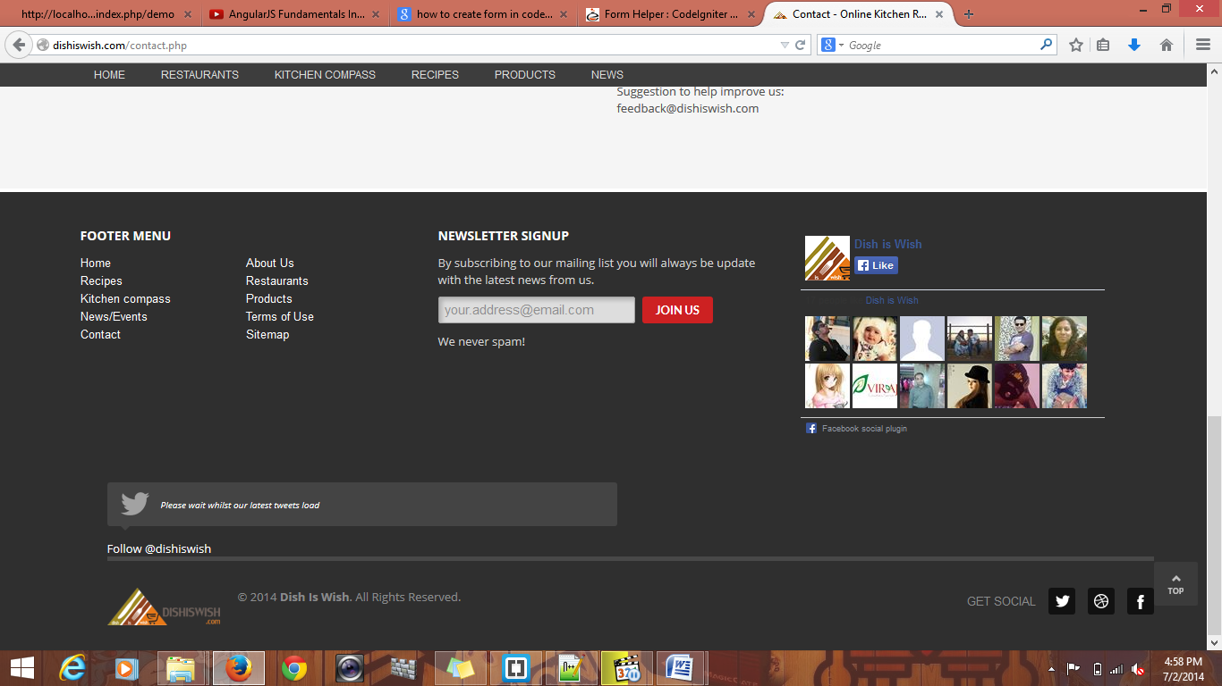

**Refer To Friend**

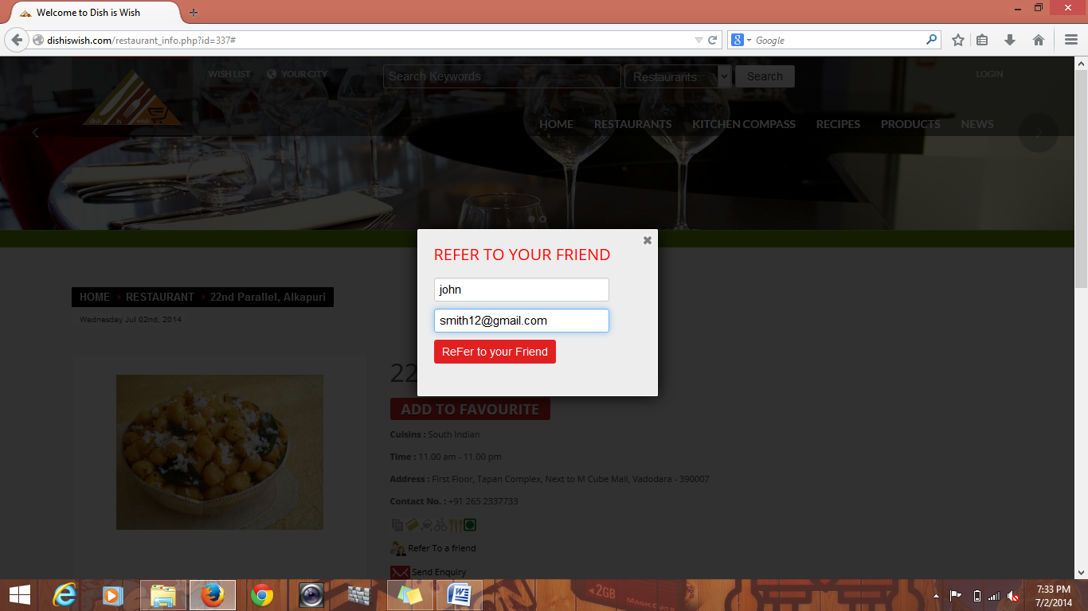

**Edit User Form**

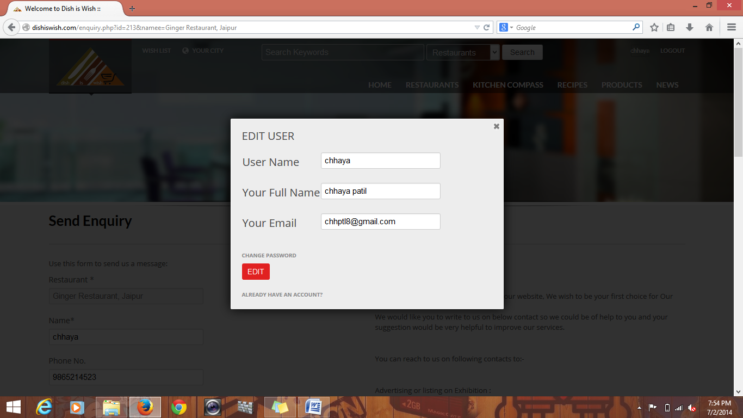

**Send Enquiry Form**

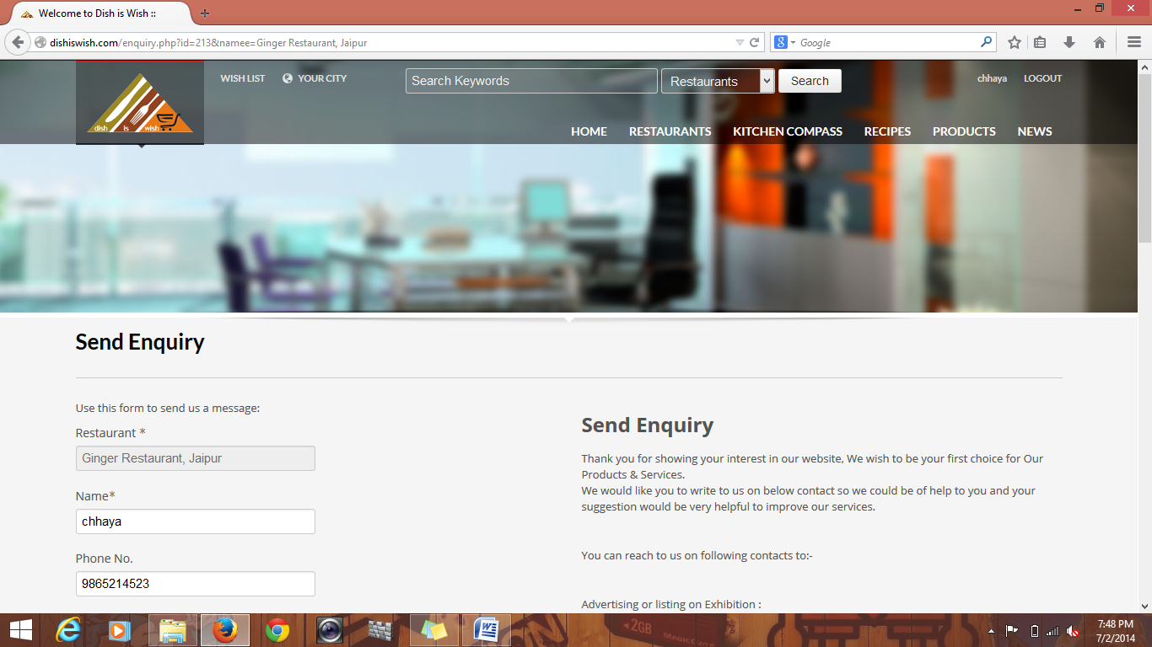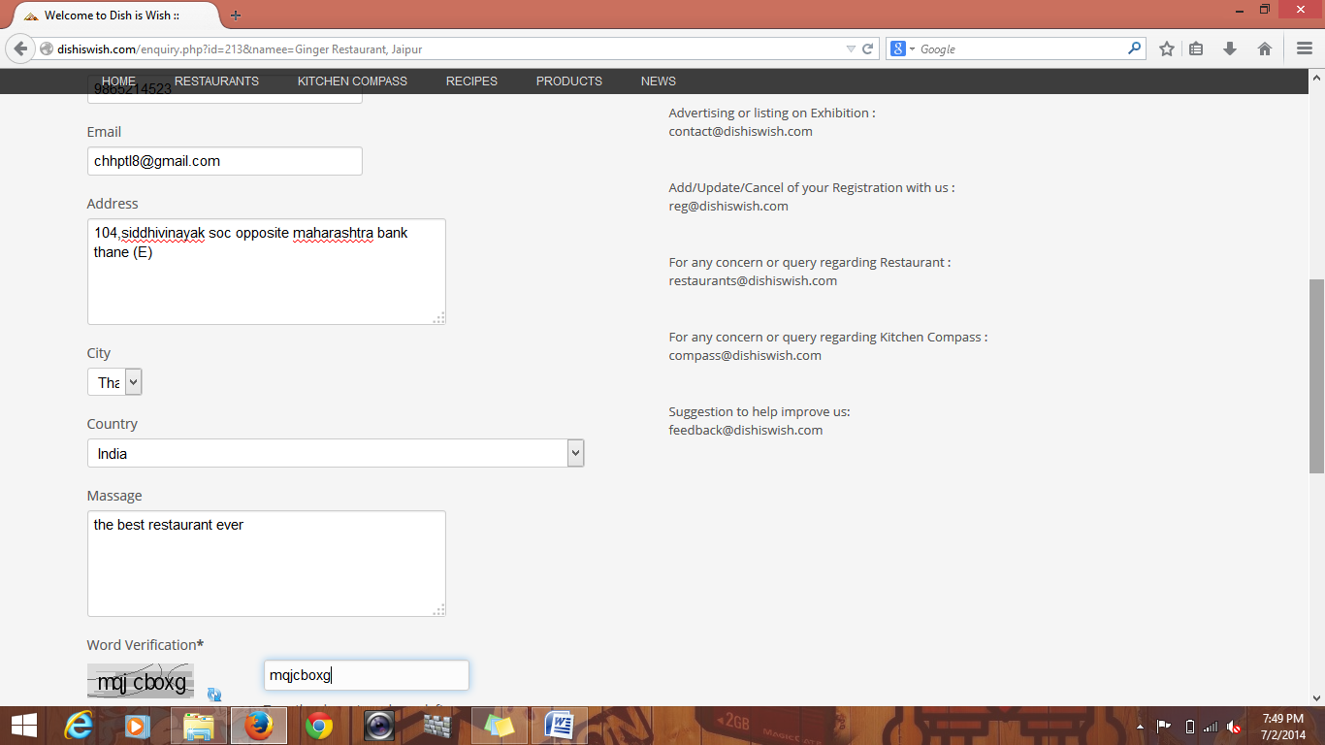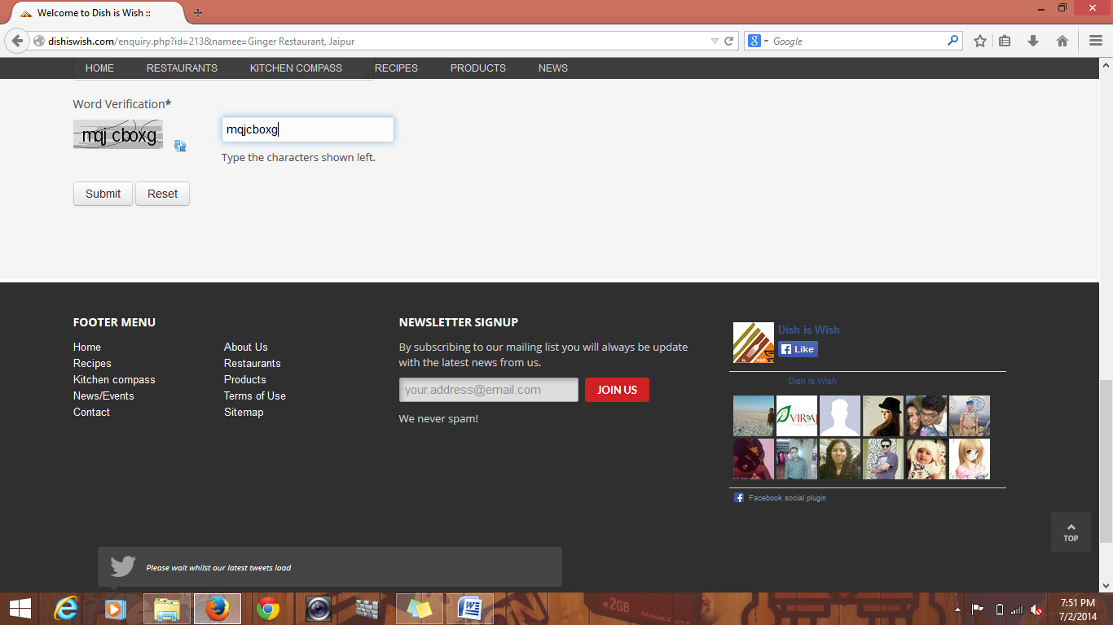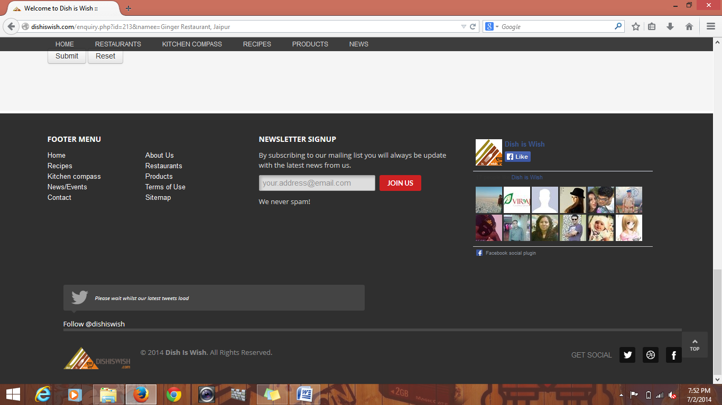

**ANNEXURE 2 : VALIDATION**

**Required Validation**

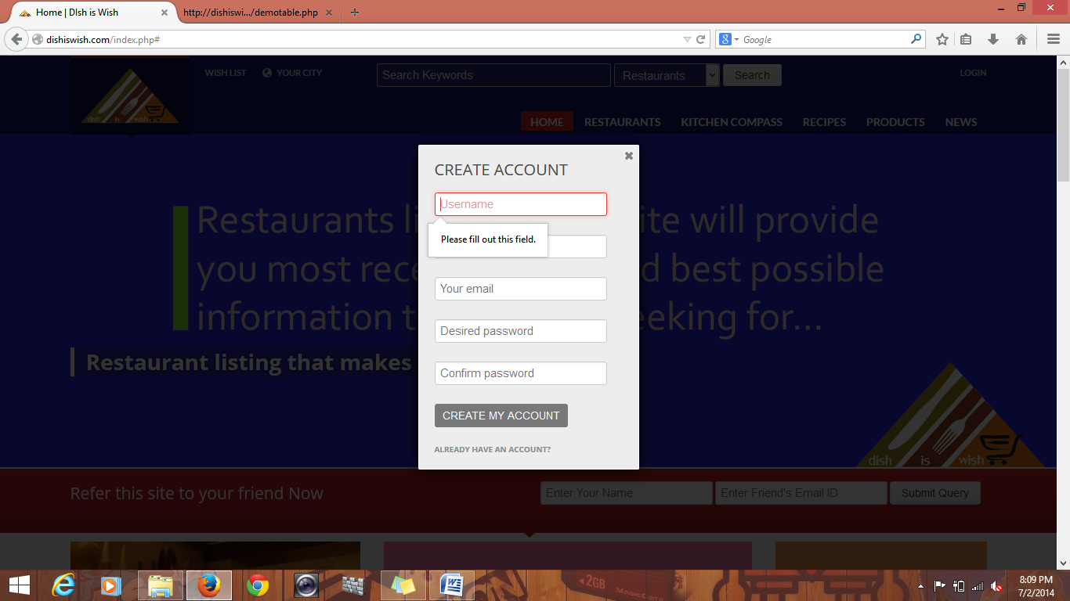

**Email Validation**

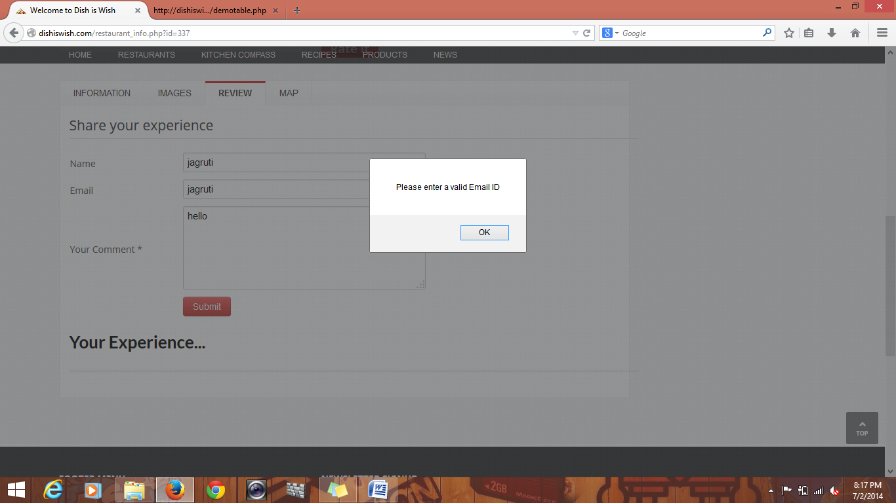

**ANNEXURE 3 : SAMPLE CODE**

**login.php**

**<?php**

**include("include/main.inc.php");**

**session_start();**

**if(isset($_POST['submit']))**

**{**

**$pass=md5($_POST['password']);**

**$qry="select * from login where username='".$_POST['username']."' and password='".$_POST['password']."'";**

**$rslt = mysql_query($qry);**

**while($arr1=mysql_fetch_array($rslt))**

**{**

**$id=$arr1['id'];**

**$_SESSION['loginid']=$arr1['0'];**

**}**

**$arr= mysql_num_rows($rslt);**

**if($arr==0)**

**{**

**$valid="Invalid Username Password.";**

**//setcookie('valid',$valid,time()+10);**

**$_SESSION['flash']="Invalid Username Password";**

**header("Location:index.php");**

**$_SESSION['flag']="0";**

**exit;**

**}**

**else**

**{**

**$name=$_POST['username'];**

**header("Location:index.php");**

**$_SESSION['id']=$id;**

**$_SESSION['flag']="1";**

**$_SESSION['name']=$name;**

**exit;**

**}**

**}**

**?>**

###### **Epilogue**

Although extensive effort has been put by myself to develop this project and full code is debugged numerous times by me, but you see there are times when things doesn’t go the way one expects them to go!

Hence in case of mistake physical or logical I hope that you will be kind enough to make me aware of my mistakes and will overlook it.

I will ensure that I will try to check that the mistakes are not repeated in future!!

**THANKING YOU!!**

**- Jagruti D. Patil**